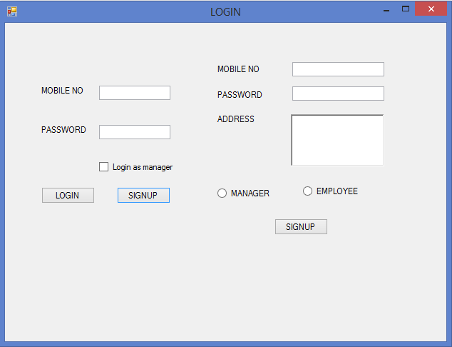

CODE:

namespace iceparlor

{

public partial class LOGIN : Form

{

public LOGIN()

{

InitializeComponent();

}

private void Form1_Load(object sender, EventArgs e)

{

Signup.Enabled = false;

Signup.Hide();

}

private void button2_Click(object sender, EventArgs e)

{

var flag="no" ;

SqlConnection con = new SqlConnection(@"Data Source=parmar\mysqlexpress;Initial Catalog=icrecreamparlor;Integrated Security=True");

con.Open();

if (checkBox1.Checked)

{

flag = "yes";

}

else

flag = "no";

SqlCommand cmd = new SqlCommand("select * from users where mobileNo='" + textBox1.Text + "' and password='" + textBox2.Text + "' and isManagar='"+flag+"';", con);

SqlDataReader dr = cmd.ExecuteReader();

if (dr.HasRows)

{

Form3 parlor = new Form3(flag);

parlor.Show();

}

else

{

MessageBox.Show("No Such Employee Found. Please Signup First");

Signup.Show();

Signup.Enabled = true;

}

con.Close();

}

private void button3_Click(object sender, EventArgs e)

{

var flag="no";

if(radioButton1.Checked)

{

flag="yes";

}

SqlConnection con = new SqlConnection(@"Data Source=parmar\mysqlexpress;Initial Catalog=icrecreamparlor;Integrated Security=True");

con.Open();

SqlCommand signup = new SqlCommand("insert into users values('"+textBox3.Text+"','"+pass.Text+"','"+richTextBox1 .Text+"','"+flag+"');",con);

int n = Convert.ToInt32(signup.ExecuteNonQuery());

if (n == 1)

{

MessageBox.Show("SUCCESSFULLY SIGNEDUP, LOGIN PLEASE");

}

}

private void button1_Click(object sender, EventArgs e)

{

Signup.Enabled = true;

Signup.Show();

}

}

}

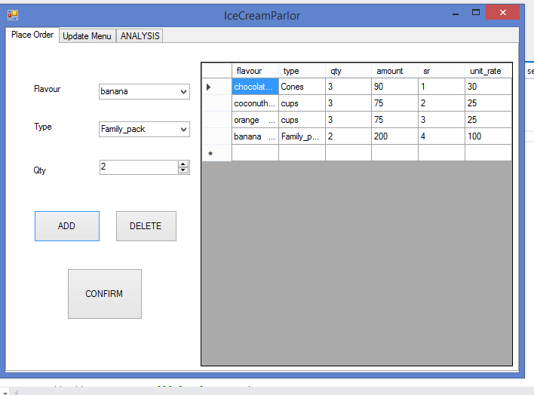

CODE:

namespace iceparlor

{

public partial class Form3 : Form

{

int price;

string type;

public Form3(string flag)

{

type = flag;

InitializeComponent();

}

private void Form3_Load(object sender, EventArgs e)

{

// TODO: This line of code loads data into the 'flavoranalyticsDataSet6.sales' table. You can move, or remove it, as needed.

this.salesTableAdapter.Fill(this.flavoranalyticsDataSet6.sales);

// TODO: This line of code loads data into the 'icrecreamparlorDataSet1.bills' table. You can move, or remove it, as needed.

this.billsTableAdapter2.Fill(this.icrecreamparlorDataSet1.bills);

// TODO: This line of code loads data into the 'billsDataSet.bills' table. You can move, or remove it, as needed.

this.billsTableAdapter1.Fill(this.billsDataSet.bills);

// TODO: This line of code loads data into the 'containerDataSet.containers' table. You can move, or remove it, as needed.

this.containersTableAdapter.Fill(this.containerDataSet.containers);

// TODO: This line of code loads data into the 'flavoursDataSet.flavors' table. You can move, or remove it, as needed.

this.flavorsTableAdapter.Fill(this.flavoursDataSet.flavors);

// TODO: This line of code loads data into the 'icrecreamparlorDataSet.bills' table. You can move, or remove it, as needed.

this.billsTableAdapter.Fill(this.icrecreamparlorDataSet.bills);

if (type == "no")

{

employeeData.Enabled = false;

viewSales.Enabled = false;

}

else

{

viewSales.Enabled = true;

employeeData.Enabled = true;

}

}

private void button1_Click(object sender, EventArgs e)

{ //ADD Button

var flavour_id= flavourBox.SelectedValue;

var container_id = containerBox.SelectedValue;

int qty = Convert.ToInt32(qtyBox.Value);

// MessageBox.Show(flavour_id.ToString()+container_id.ToString()+qty.ToString());

try

{

SqlConnection con = new SqlConnection(@"Data Source=parmar\mysqlexpress;Initial Catalog=icrecreamparlor;Integrated Security=True");

con.Open();

SqlDataAdapter adp_price = new SqlDataAdapter("select price from menu where flavour_id=" + flavour_id + " and container_id=" + container_id + ";", con);

DataTable dt1 = new DataTable();

adp_price.Fill(dt1);

price = Convert.ToInt32(dt1.Rows[0][0]);

SqlDataAdapter adp_flavourname = new SqlDataAdapter("select flavour_name from flavors where flavour_id=" + flavour_id + ";", con);

DataTable dt2 = new DataTable();

adp_flavourname.Fill(dt2);

var flavour_name = dt2.Rows[0][0];

SqlDataAdapter adp_containername = new SqlDataAdapter("select container_name from containers where container_id=" + container_id + ";", con);

DataTable dt3 = new DataTable();

adp_containername.Fill(dt3);

var container_name = dt3.Rows[0][0];

SqlCommand billupdate = new SqlCommand("INSERT INTO bills ([flavour] ,[type],[qty],[amount] ,[flavour_id] ,[container_id],[unit_rate]) VALUES('" + flavour_name + "','" + container_name + " ','" + qty + " ','" + price * qty + " ','" + flavour_id + " ','" + container_id + " ','" + price + "' );", con);

int n = Convert.ToInt32(billupdate.ExecuteNonQuery());

if (n == 1)

{

SqlDataAdapter adp_update = new SqlDataAdapter("SELECT [sr],[flavour],[type],[qty],[unit_rate],[amount] FRom bills;", con);

DataTable dt4 = new DataTable();

adp_update.Fill(dt4);

BindingSource updatebindingSource = new BindingSource();

updatebindingSource.DataSource = dt4;

billView.DataSource = updatebindingSource;

con.Close();

}

}

catch (Exception ex)

{

MessageBox.Show("NOT AVAILABLE");

}

}

private void flavourBox_SelectedIndexChanged(object sender, EventArgs e)

{

flavourBox.Refresh();

}

private void button2_Click(object sender, EventArgs e)

{

//DELETE button

DataGridViewSelectedRowCollection row = billView.SelectedRows;

var id = row[0].Cells[4].Value;

SqlConnection con = new SqlConnection(@"Data Source=parmar\mysqlexpress;Initial Catalog=icrecreamparlor;Integrated Security=True");

con.Open();

SqlCommand billupdate = new SqlCommand("delete from bills where sr='" + id + "';", con);

int n = billupdate.ExecuteNonQuery();

if (n == 1){

SqlDataAdapter adp_update = new SqlDataAdapter("SELECT [sr],[flavour],[type],[qty],[unit_rate],[amount] FRom bills;", con);

DataTable dt4 = new DataTable();

adp_update.Fill(dt4);

BindingSource updatebindingSource = new BindingSource();

updatebindingSource.DataSource = dt4;

billView.DataSource = updatebindingSource;

con.Close();

}

}

private void button3_Click(object sender, EventArgs e)

{

//PRINT button

int n;

var date = System.DateTime.Now.ToShortDateString();

SqlConnection con = new SqlConnection(@"Data Source=parmar\mysqlexpress;Initial Catalog=icrecreamparlor;Integrated Security=True");

con.Open();

SqlDataAdapter adp_fillsales = new SqlDataAdapter("select * from bills;",con);

DataTable dtBills= new DataTable();

adp_fillsales.Fill(dtBills);

var user_id=1;

con.Close();

foreach (DataColumn col in dtBills.Columns)

{

con.Open();

foreach (DataRow row in dtBills.Rows)

{

var a=row.ItemArray;

SqlCommand addToSales = new SqlCommand("INSERT INTO sales ([flavour_id],[container_id],[user_id],[quantity],[date],[total],[unit_rate]) VALUES(" + a[6] + "," + a[5] + " ," + user_id + " ," + a[2] + " ,'" + date + " '," + a[3] + " , " + a[7] + ");", con);

n = addToSales.ExecuteNonQuery();

}

con.Close();

}

//convert to word baki hai

con.Open();

SqlCommand truncate_bills = new SqlCommand("truncate table bills;",con);

n = truncate_bills.ExecuteNonQuery();

SqlDataAdapter adp_update = new SqlDataAdapter("SELECT [sr],[flavour],[type],[qty],[unit_rate],[amount] FRom bills;", con);

DataTable dt4 = new DataTable();

adp_update.Fill(dt4);

BindingSource updatebindingSource = new BindingSource();

updatebindingSource.DataSource = dt4;

billView.DataSource = updatebindingSource;

con.Close();

}

private void label4_Click(object sender, EventArgs e)

{

}

private void button6_Click(object sender, EventArgs e)

{

MENU menu = new MENU();

menu.Show();

}

private void tabPage2_Click(object sender, EventArgs e)

{

}

private void addFlavors_Click(object sender, EventArgs e)

{

addFlavor add = new addFlavor();

add.Show();

}

private void button9_Click(object sender, EventArgs e)

{

Sales sales = new Sales();

sales.Show();

}

private void button5_Click(object sender, EventArgs e)

{

CONTAINERS con = new CONTAINERS();

con.Show();

}

private void button4_Click(object sender, EventArgs e)

{

Employee_info emp = new Employee_info();

emp.Show();

}

private void button4_Click_1(object sender, EventArgs e)

{

SqlConnection con = new SqlConnection(@"Data Source=parmar\mysqlexpress;Initial Catalog=icrecreamparlor;Integrated Security=True");

con.Open();

SqlDataAdapter adp_update = new SqlDataAdapter("select flavour_id,SUM(total) as Amount,SUM(quantity) as Units from sales where date between '"+textBox1.Text+"' and '"+textBox2.Text+"' group by flavour_id;", con);

DataTable dt4 = new DataTable();

adp_update.Fill(dt4);

BindingSource updatebindingSource = new BindingSource();

updatebindingSource.DataSource = dt4;

dataGridView1.DataSource = updatebindingSource;

con.Close();

}

private void button7_Click(object sender, EventArgs e)

{

SqlConnection con = new SqlConnection(@"Data Source=parmar\mysqlexpress;Initial Catalog=icrecreamparlor;Integrated Security=True");

con.Open();

SqlDataAdapter adp_update = new SqlDataAdapter("select flavour_id,SUM(total) as Amount,SUM(quantity) as Units from sales where date between '" + textBox1.Text + "' and '" + textBox2.Text + "' group by flavour_id;", con);

DataTable dt4 = new DataTable();

adp_update.Fill(dt4);

BindingSource updatebindingSource = new BindingSource();

updatebindingSource.DataSource = dt4;

dataGridView1.DataSource = updatebindingSource;

con.Close();

}

}

}

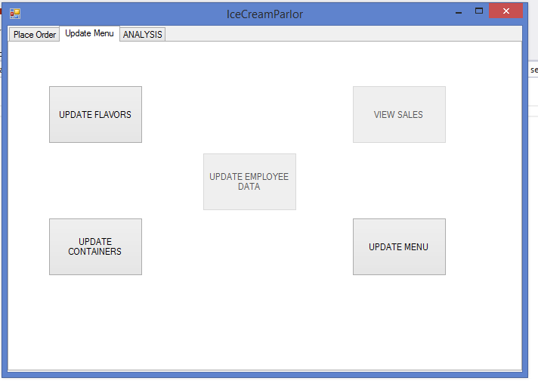

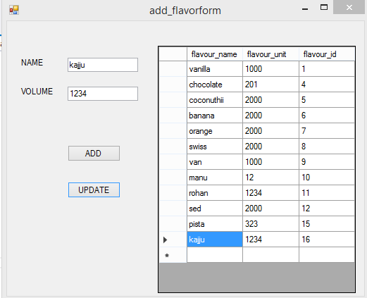

CODE:

namespace iceparlor

{

public partial class addFlavor : Form

{

public addFlavor()

{

InitializeComponent();

}

private void add_flavorform_Load(object sender, EventArgs e)

{

// TODO: This line of code loads data into the 'addFlavorsDataSet2.flavors' table. You can move, or remove it, as needed.

this.flavorsTableAdapter.Fill(this.addFlavorsDataSet2.flavors);

}

private void addFlavour_Click(object sender, EventArgs e)

{

var flavour_name = addname.Text;

var volume = addvolume.Text;

int n = 0;

SqlConnection con = new SqlConnection(@"Data Source=parmar\mysqlexpress;Initial Catalog=icrecreamparlor;Integrated Security=True");

con.Open();

try

{

SqlCommand addFlavor = new SqlCommand("insert into flavors values('" + flavour_name + "','" + volume + "');", con);

n = Convert.ToInt32(addFlavor.ExecuteNonQuery());

}

catch (Exception addFlavException)

{

MessageBox.Show("Please enter unique flavours.");

}

if (n == 1)

{

SqlDataAdapter adp_update = new SqlDataAdapter("SELECT * FRom flavors;", con);

DataTable dt4 = new DataTable();

adp_update.Fill(dt4);

BindingSource updatebindingSource = new BindingSource();

updatebindingSource.DataSource = dt4;

flavorsBindingSource.DataSource = updatebindingSource;

con.Close();

}

}

private void deleteFlavor_Click(object sender, EventArgs e)

{

DataGridViewSelectedRowCollection row = addGridVIew.SelectedRows;

var id = row[0].Cells[2].Value;

var flavour_name = row[0].Cells[0].Value;

var volume = row[0].Cells[1].Value;

SqlConnection con = new SqlConnection(@"Data Source=parmar\mysqlexpress;Initial Catalog=icrecreamparlor;Integrated Security=True");

con.Open();

SqlCommand deleteflavor = new SqlCommand("delete from flavors where flavour_id='" + id + "';", con);

int n = deleteflavor.ExecuteNonQuery();

if (n == 1)

{

SqlDataAdapter adp_update = new SqlDataAdapter("SELECT * FRom flavors;", con);

DataTable dt4 = new DataTable();

adp_update.Fill(dt4);

BindingSource updatebindingSource = new BindingSource();

updatebindingSource.DataSource = dt4;

flavorsBindingSource.DataSource = updatebindingSource;

con.Close();

}

}

private void updateflavor_Click(object sender, EventArgs e)

{

DataGridViewSelectedRowCollection row = addGridVIew.SelectedRows;

var id = row[0].Cells[2].Value;

SqlConnection con = new SqlConnection(@"Data Source=parmar\mysqlexpress;Initial Catalog=icrecreamparlor;Integrated Security=True");

con.Open();

SqlCommand adp_updateflavor1 = new SqlCommand("update flavors set flavour_name='" + addname.Text + "' where flavour_id='"+id+"';", con);

int n1 = adp_updateflavor1.ExecuteNonQuery();

SqlCommand adp_updateflavor2 = new SqlCommand("update flavors set flavour_unit='" + addvolume.Text + "'where flavour_id='" + id + "';", con);

int n2 = adp_updateflavor2.ExecuteNonQuery();

if (n1 == 1 && n2 == 1)

{

SqlDataAdapter adp_update = new SqlDataAdapter("SELECT * FRom flavors;", con);

DataTable dt4 = new DataTable();

adp_update.Fill(dt4);

BindingSource updatebindingSource = new BindingSource();

updatebindingSource.DataSource = dt4;

flavorsBindingSource.DataSource = updatebindingSource;

con.Close();

}

}

private void addGridVIew_CellClick(object sender, DataGridViewCellEventArgs e)

{

try

{

DataGridViewSelectedRowCollection row = addGridVIew.SelectedRows;

addname.Text = row[0].Cells[0].Value.ToString();

addvolume.Text = row[0].Cells[1].Value.ToString();

}

catch(Exception ex)

{}

}

}

}

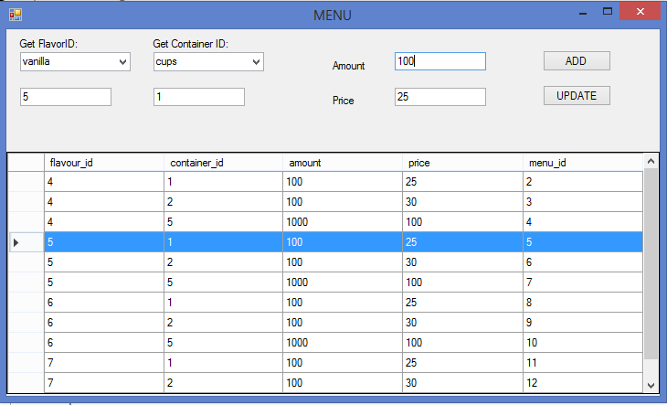

CODE:

namespace iceparlor

{

public partial class Form3 : Form

{

int price;

string type;

public Form3(string flag)

{

type = flag;

InitializeComponent();

}

private void Form3_Load(object sender, EventArgs e)

{

// TODO: This line of code loads data into the 'flavoranalyticsDataSet6.sales' table. You can move, or remove it, as needed.

this.salesTableAdapter.Fill(this.flavoranalyticsDataSet6.sales);

// TODO: This line of code loads data into the 'icrecreamparlorDataSet1.bills' table. You can move, or remove it, as needed.

this.billsTableAdapter2.Fill(this.icrecreamparlorDataSet1.bills);

// TODO: This line of code loads data into the 'billsDataSet.bills' table. You can move, or remove it, as needed.

this.billsTableAdapter1.Fill(this.billsDataSet.bills);

// TODO: This line of code loads data into the 'containerDataSet.containers' table. You can move, or remove it, as needed.

this.containersTableAdapter.Fill(this.containerDataSet.containers);

// TODO: This line of code loads data into the 'flavoursDataSet.flavors' table. You can move, or remove it, as needed.

this.flavorsTableAdapter.Fill(this.flavoursDataSet.flavors);

// TODO: This line of code loads data into the 'icrecreamparlorDataSet.bills' table. You can move, or remove it, as needed.

this.billsTableAdapter.Fill(this.icrecreamparlorDataSet.bills);

if (type == "no")

{

employeeData.Enabled = false;

viewSales.Enabled = false;

}

else

{

viewSales.Enabled = true;

employeeData.Enabled = true;

}

}

private void button1_Click(object sender, EventArgs e)

{ //ADD Button

var flavour_id= flavourBox.SelectedValue;

var container_id = containerBox.SelectedValue;

int qty = Convert.ToInt32(qtyBox.Value);

// MessageBox.Show(flavour_id.ToString()+container_id.ToString()+qty.ToString());

try

{

SqlConnection con = new SqlConnection(@"Data Source=parmar\mysqlexpress;Initial Catalog=icrecreamparlor;Integrated Security=True");

con.Open();

SqlDataAdapter adp_price = new SqlDataAdapter("select price from menu where flavour_id=" + flavour_id + " and container_id=" + container_id + ";", con);

DataTable dt1 = new DataTable();

adp_price.Fill(dt1);

price = Convert.ToInt32(dt1.Rows[0][0]);

SqlDataAdapter adp_flavourname = new SqlDataAdapter("select flavour_name from flavors where flavour_id=" + flavour_id + ";", con);

DataTable dt2 = new DataTable();

adp_flavourname.Fill(dt2);

var flavour_name = dt2.Rows[0][0];

SqlDataAdapter adp_containername = new SqlDataAdapter("select container_name from containers where container_id=" + container_id + ";", con);

DataTable dt3 = new DataTable();

adp_containername.Fill(dt3);

var container_name = dt3.Rows[0][0];

SqlCommand billupdate = new SqlCommand("INSERT INTO bills ([flavour] ,[type],[qty],[amount] ,[flavour_id] ,[container_id],[unit_rate]) VALUES('" + flavour_name + "','" + container_name + " ','" + qty + " ','" + price * qty + " ','" + flavour_id + " ','" + container_id + " ','" + price + "' );", con);

int n = Convert.ToInt32(billupdate.ExecuteNonQuery());

if (n == 1)

{

SqlDataAdapter adp_update = new SqlDataAdapter("SELECT [sr],[flavour],[type],[qty],[unit_rate],[amount] FRom bills;", con);

DataTable dt4 = new DataTable();

adp_update.Fill(dt4);

BindingSource updatebindingSource = new BindingSource();

updatebindingSource.DataSource = dt4;

billView.DataSource = updatebindingSource;

con.Close();

}

}

catch (Exception ex)

{

MessageBox.Show("NOT AVAILABLE");

}

}

private void flavourBox_SelectedIndexChanged(object sender, EventArgs e)

{

flavourBox.Refresh();

}

private void button2_Click(object sender, EventArgs e)

{

//DELETE button

DataGridViewSelectedRowCollection row = billView.SelectedRows;

var id = row[0].Cells[4].Value;

SqlConnection con = new SqlConnection(@"Data Source=parmar\mysqlexpress;Initial Catalog=icrecreamparlor;Integrated Security=True");

con.Open();

SqlCommand billupdate = new SqlCommand("delete from bills where sr='" + id + "';", con);

int n = billupdate.ExecuteNonQuery();

if (n == 1){

SqlDataAdapter adp_update = new SqlDataAdapter("SELECT [sr],[flavour],[type],[qty],[unit_rate],[amount] FRom bills;", con);

DataTable dt4 = new DataTable();

adp_update.Fill(dt4);

BindingSource updatebindingSource = new BindingSource();

updatebindingSource.DataSource = dt4;

billView.DataSource = updatebindingSource;

con.Close();

}

}

private void button3_Click(object sender, EventArgs e)

{

//PRINT button

int n;

var date = System.DateTime.Now.ToShortDateString();

SqlConnection con = new SqlConnection(@"Data Source=parmar\mysqlexpress;Initial Catalog=icrecreamparlor;Integrated Security=True");

con.Open();

SqlDataAdapter adp_fillsales = new SqlDataAdapter("select * from bills;",con);

DataTable dtBills= new DataTable();

adp_fillsales.Fill(dtBills);

var user_id=1;

con.Close();

foreach (DataColumn col in dtBills.Columns)

{

con.Open();

foreach (DataRow row in dtBills.Rows)

{

var a=row.ItemArray;

SqlCommand addToSales = new SqlCommand("INSERT INTO sales ([flavour_id],[container_id],[user_id],[quantity],[date],[total],[unit_rate]) VALUES(" + a[6] + "," + a[5] + " ," + user_id + " ," + a[2] + " ,'" + date + " '," + a[3] + " , " + a[7] + ");", con);

n = addToSales.ExecuteNonQuery();

}

con.Close();

}

//convert to word baki hai

con.Open();

SqlCommand truncate_bills = new SqlCommand("truncate table bills;",con);

n = truncate_bills.ExecuteNonQuery();

SqlDataAdapter adp_update = new SqlDataAdapter("SELECT [sr],[flavour],[type],[qty],[unit_rate],[amount] FRom bills;", con);

DataTable dt4 = new DataTable();

adp_update.Fill(dt4);

BindingSource updatebindingSource = new BindingSource();

updatebindingSource.DataSource = dt4;

billView.DataSource = updatebindingSource;

con.Close();

}

private void label4_Click(object sender, EventArgs e)

{

}

private void button6_Click(object sender, EventArgs e)

{

MENU menu = new MENU();

menu.Show();

}

private void tabPage2_Click(object sender, EventArgs e)

{

}

private void addFlavors_Click(object sender, EventArgs e)

{

addFlavor add = new addFlavor();

add.Show();

}

private void button9_Click(object sender, EventArgs e)

{

Sales sales = new Sales();

sales.Show();

}

private void button5_Click(object sender, EventArgs e)

{

CONTAINERS con = new CONTAINERS();

con.Show();

}

private void button4_Click(object sender, EventArgs e)

{

Employee_info emp = new Employee_info();

emp.Show();

}

private void button4_Click_1(object sender, EventArgs e)

{

SqlConnection con = new SqlConnection(@"Data Source=parmar\mysqlexpress;Initial Catalog=icrecreamparlor;Integrated Security=True");

con.Open();

SqlDataAdapter adp_update = new SqlDataAdapter("select flavour_id,SUM(total) as Amount,SUM(quantity) as Units from sales where date between '"+textBox1.Text+"' and '"+textBox2.Text+"' group by flavour_id;", con);

DataTable dt4 = new DataTable();

adp_update.Fill(dt4);

BindingSource updatebindingSource = new BindingSource();

updatebindingSource.DataSource = dt4;

dataGridView1.DataSource = updatebindingSource;

con.Close();

}

private void button7_Click(object sender, EventArgs e)

{

SqlConnection con = new SqlConnection(@"Data Source=parmar\mysqlexpress;Initial Catalog=icrecreamparlor;Integrated Security=True");

con.Open();

SqlDataAdapter adp_update = new SqlDataAdapter("select flavour_id,SUM(total) as Amount,SUM(quantity) as Units from sales where date between '" + textBox1.Text + "' and '" + textBox2.Text + "' group by flavour_id;", con);

DataTable dt4 = new DataTable();

adp_update.Fill(dt4);

BindingSource updatebindingSource = new BindingSource();

updatebindingSource.DataSource = dt4;

dataGridView1.DataSource = updatebindingSource;

con.Close();

}

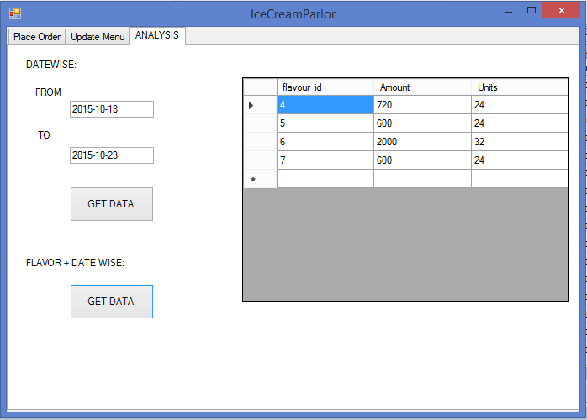

CODE:

namespace iceparlor

{

public partial class Form3 : Form

{

int price;

string type;

public Form3(string flag)

{

type = flag;

InitializeComponent();

}

private void Form3_Load(object sender, EventArgs e)

{

// TODO: This line of code loads data into the 'flavoranalyticsDataSet6.sales' table. You can move, or remove it, as needed.

this.salesTableAdapter.Fill(this.flavoranalyticsDataSet6.sales);

// TODO: This line of code loads data into the 'icrecreamparlorDataSet1.bills' table. You can move, or remove it, as needed.

this.billsTableAdapter2.Fill(this.icrecreamparlorDataSet1.bills);

// TODO: This line of code loads data into the 'billsDataSet.bills' table. You can move, or remove it, as needed.

this.billsTableAdapter1.Fill(this.billsDataSet.bills);

// TODO: This line of code loads data into the 'containerDataSet.containers' table. You can move, or remove it, as needed.

this.containersTableAdapter.Fill(this.containerDataSet.containers);

// TODO: This line of code loads data into the 'flavoursDataSet.flavors' table. You can move, or remove it, as needed.

this.flavorsTableAdapter.Fill(this.flavoursDataSet.flavors);

// TODO: This line of code loads data into the 'icrecreamparlorDataSet.bills' table. You can move, or remove it, as needed.

this.billsTableAdapter.Fill(this.icrecreamparlorDataSet.bills);

if (type == "no")

{

employeeData.Enabled = false;

viewSales.Enabled = false;

}

else

{

viewSales.Enabled = true;

employeeData.Enabled = true;

}

}

private void button1_Click(object sender, EventArgs e)

{ //ADD Button

var flavour_id= flavourBox.SelectedValue;

var container_id = containerBox.SelectedValue;

int qty = Convert.ToInt32(qtyBox.Value);

// MessageBox.Show(flavour_id.ToString()+container_id.ToString()+qty.ToString());

try

{

SqlConnection con = new SqlConnection(@"Data Source=parmar\mysqlexpress;Initial Catalog=icrecreamparlor;Integrated Security=True");

con.Open();

SqlDataAdapter adp_price = new SqlDataAdapter("select price from menu where flavour_id=" + flavour_id + " and container_id=" + container_id + ";", con);

DataTable dt1 = new DataTable();

adp_price.Fill(dt1);

price = Convert.ToInt32(dt1.Rows[0][0]);

SqlDataAdapter adp_flavourname = new SqlDataAdapter("select flavour_name from flavors where flavour_id=" + flavour_id + ";", con);

DataTable dt2 = new DataTable();

adp_flavourname.Fill(dt2);

var flavour_name = dt2.Rows[0][0];

SqlDataAdapter adp_containername = new SqlDataAdapter("select container_name from containers where container_id=" + container_id + ";", con);

DataTable dt3 = new DataTable();

adp_containername.Fill(dt3);

var container_name = dt3.Rows[0][0];

SqlCommand billupdate = new SqlCommand("INSERT INTO bills ([flavour] ,[type],[qty],[amount] ,[flavour_id] ,[container_id],[unit_rate]) VALUES('" + flavour_name + "','" + container_name + " ','" + qty + " ','" + price * qty + " ','" + flavour_id + " ','" + container_id + " ','" + price + "' );", con);

int n = Convert.ToInt32(billupdate.ExecuteNonQuery());

if (n == 1)

{

SqlDataAdapter adp_update = new SqlDataAdapter("SELECT [sr],[flavour],[type],[qty],[unit_rate],[amount] FRom bills;", con);

DataTable dt4 = new DataTable();

adp_update.Fill(dt4);

BindingSource updatebindingSource = new BindingSource();

updatebindingSource.DataSource = dt4;

billView.DataSource = updatebindingSource;

con.Close();

}

}

catch (Exception ex)

{

MessageBox.Show("NOT AVAILABLE");

}

}

private void flavourBox_SelectedIndexChanged(object sender, EventArgs e)

{

flavourBox.Refresh();

}

private void button2_Click(object sender, EventArgs e)

{

//DELETE button

DataGridViewSelectedRowCollection row = billView.SelectedRows;

var id = row[0].Cells[4].Value;

SqlConnection con = new SqlConnection(@"Data Source=parmar\mysqlexpress;Initial Catalog=icrecreamparlor;Integrated Security=True");

con.Open();

SqlCommand billupdate = new SqlCommand("delete from bills where sr='" + id + "';", con);

int n = billupdate.ExecuteNonQuery();

if (n == 1){

SqlDataAdapter adp_update = new SqlDataAdapter("SELECT [sr],[flavour],[type],[qty],[unit_rate],[amount] FRom bills;", con);

DataTable dt4 = new DataTable();

adp_update.Fill(dt4);

BindingSource updatebindingSource = new BindingSource();

updatebindingSource.DataSource = dt4;

billView.DataSource = updatebindingSource;

con.Close();

}

}

private void button3_Click(object sender, EventArgs e)

{

//PRINT button

int n;

var date = System.DateTime.Now.ToShortDateString();

SqlConnection con = new SqlConnection(@"Data Source=parmar\mysqlexpress;Initial Catalog=icrecreamparlor;Integrated Security=True");

con.Open();

SqlDataAdapter adp_fillsales = new SqlDataAdapter("select * from bills;",con);

DataTable dtBills= new DataTable();

adp_fillsales.Fill(dtBills);

var user_id=1;

con.Close();

foreach (DataColumn col in dtBills.Columns)

{

con.Open();

foreach (DataRow row in dtBills.Rows)

{

var a=row.ItemArray;

SqlCommand addToSales = new SqlCommand("INSERT INTO sales ([flavour_id],[container_id],[user_id],[quantity],[date],[total],[unit_rate]) VALUES(" + a[6] + "," + a[5] + " ," + user_id + " ," + a[2] + " ,'" + date + " '," + a[3] + " , " + a[7] + ");", con);

n = addToSales.ExecuteNonQuery();

}

con.Close();

}

//convert to word baki hai

con.Open();

SqlCommand truncate_bills = new SqlCommand("truncate table bills;",con);

n = truncate_bills.ExecuteNonQuery();

SqlDataAdapter adp_update = new SqlDataAdapter("SELECT [sr],[flavour],[type],[qty],[unit_rate],[amount] FRom bills;", con);

DataTable dt4 = new DataTable();

adp_update.Fill(dt4);

BindingSource updatebindingSource = new BindingSource();

updatebindingSource.DataSource = dt4;

billView.DataSource = updatebindingSource;

con.Close();

}

private void label4_Click(object sender, EventArgs e)

{

}

private void button6_Click(object sender, EventArgs e)

{

MENU menu = new MENU();

menu.Show();

}

private void tabPage2_Click(object sender, EventArgs e)

{

}

private void addFlavors_Click(object sender, EventArgs e)

{

addFlavor add = new addFlavor();

add.Show();

}

private void button9_Click(object sender, EventArgs e)

{

Sales sales = new Sales();

sales.Show();

}

private void button5_Click(object sender, EventArgs e)

{

CONTAINERS con = new CONTAINERS();

con.Show();

}

private void button4_Click(object sender, EventArgs e)

{

Employee_info emp = new Employee_info();

emp.Show();

}

private void button4_Click_1(object sender, EventArgs e)

{

SqlConnection con = new SqlConnection(@"Data Source=parmar\mysqlexpress;Initial Catalog=icrecreamparlor;Integrated Security=True");

con.Open();

SqlDataAdapter adp_update = new SqlDataAdapter("select flavour_id,SUM(total) as Amount,SUM(quantity) as Units from sales where date between '"+textBox1.Text+"' and '"+textBox2.Text+"' group by flavour_id;", con);

DataTable dt4 = new DataTable();

adp_update.Fill(dt4);

BindingSource updatebindingSource = new BindingSource();

updatebindingSource.DataSource = dt4;

dataGridView1.DataSource = updatebindingSource;

con.Close();

}

private void button7_Click(object sender, EventArgs e)

{

SqlConnection con = new SqlConnection(@"Data Source=parmar\mysqlexpress;Initial Catalog=icrecreamparlor;Integrated Security=True");

con.Open();

SqlDataAdapter adp_update = new SqlDataAdapter("select flavour_id,SUM(total) as Amount,SUM(quantity) as Units from sales where date between '" + textBox1.Text + "' and '" + textBox2.Text + "' group by flavour_id;", con);

DataTable dt4 = new DataTable();

adp_update.Fill(dt4);

BindingSource updatebindingSource = new BindingSource();

updatebindingSource.DataSource = dt4;

dataGridView1.DataSource = updatebindingSource;

con.Close();

}